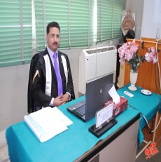

*C.V*

***Romany Anees Mourad Boktor***

*Assistant lecturer, Accounting Depart., Faculty of Commerce, Asyut University, Egypt*

*Tel. +2 088*

*Mob. +201025512122*

*Address:.Assiut*

*E-mail: romany_am*[*@aun.edu.eg*](mailto:sally_ea@aun.edu.eg)

***Qualifications:-***

*Bachelor degree in accounting, Faculty of Commerce. Assiut University, Egypt, Grade "very good with Honour Grade", June 2001*

***Post-graduate Studies:-***

* *Master degree in Accounting "Cost Accounting", july 2012, Research Title "Developing The Cost Information System to Rationalize Maintenance Decisions With Application on Misr Aluminum Company"*
* *Doctoral Studies in Accounting to obtain Ph.D. degree*

***Occupational Experiences:-***

* *Sep.2012-Uptil now: working as Assistant Lecturer in Accounting*

*Depart, Faculty of Commerce, Assuit University*

* *Feb.2002-Aug.2012: working as Demonstrator in Accounting Depart,*

*Faculty of Commerce, Assuit University, Egypt*

***Special Studies:-***

* *Local TOEFEL Feb.2011*
* *Training courses in skills development (7 courses) from the Faculty & Leadership Development Center(FLDC), Assiut University.*
* *Essential Training Course No.(7) in Information Technology related to The Ministry of Communications and Informations.*

***Special Skills:-***

* *Good interpersonal and social communicative skills*
* *Leadership skills and capability to work under pressure*

***Personal Data:-***

* *Place of birth: Assiut*
* *Date of birth: 14-04-1979*
* *Marital status: Married*

***, All Documents are available upon request****.*